# CS 255 System Design Document Template

## UML Diagrams

### UML Use Case Diagram

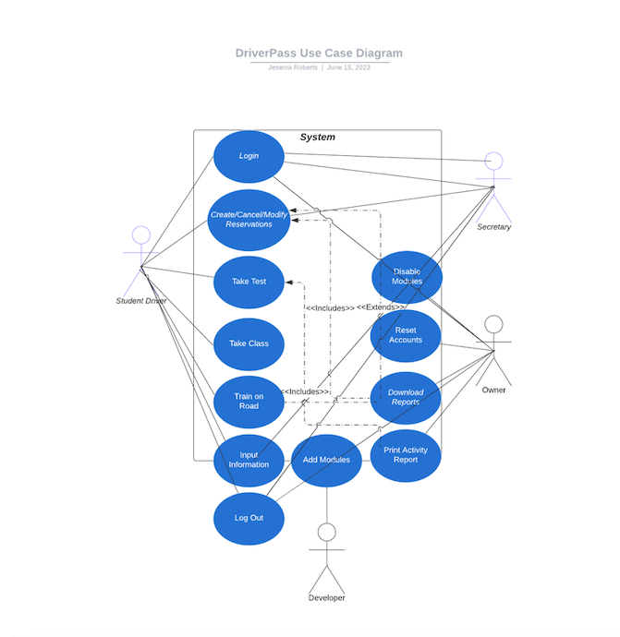

### UML Activity Diagrams

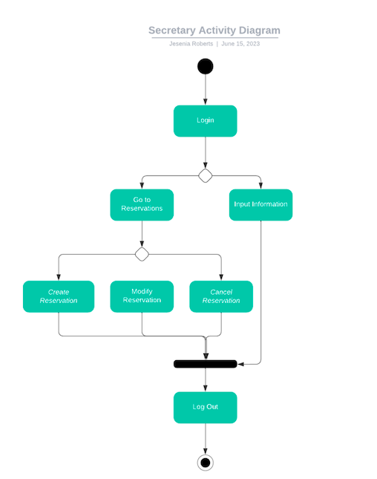

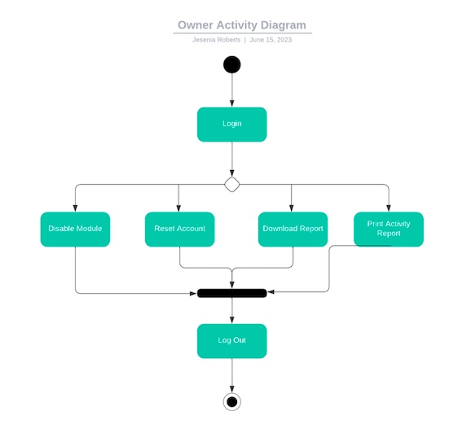

### UML Sequence Diagram

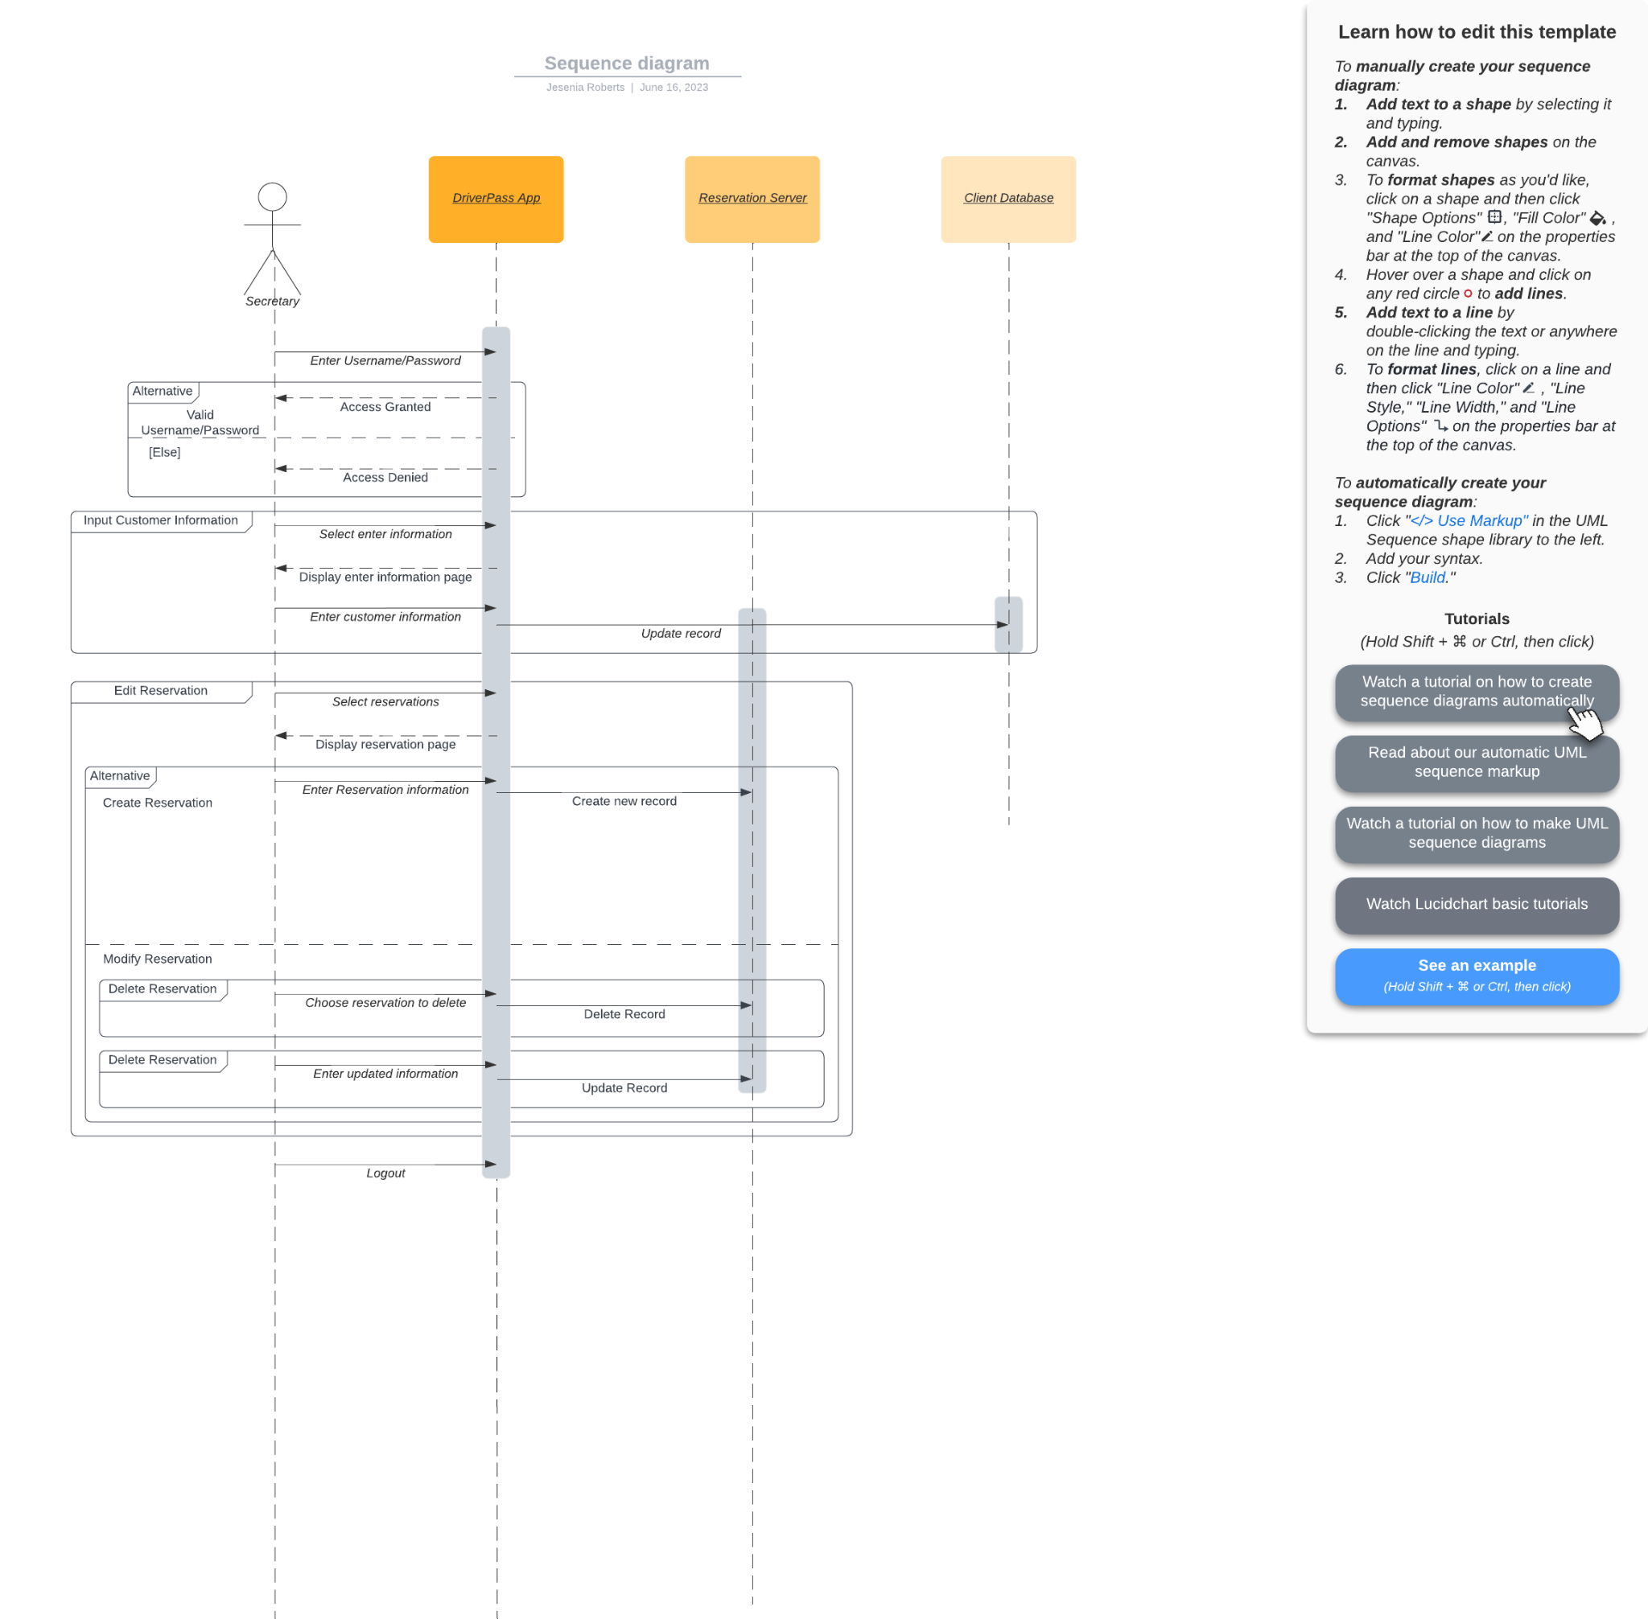

### UML Class Diagram

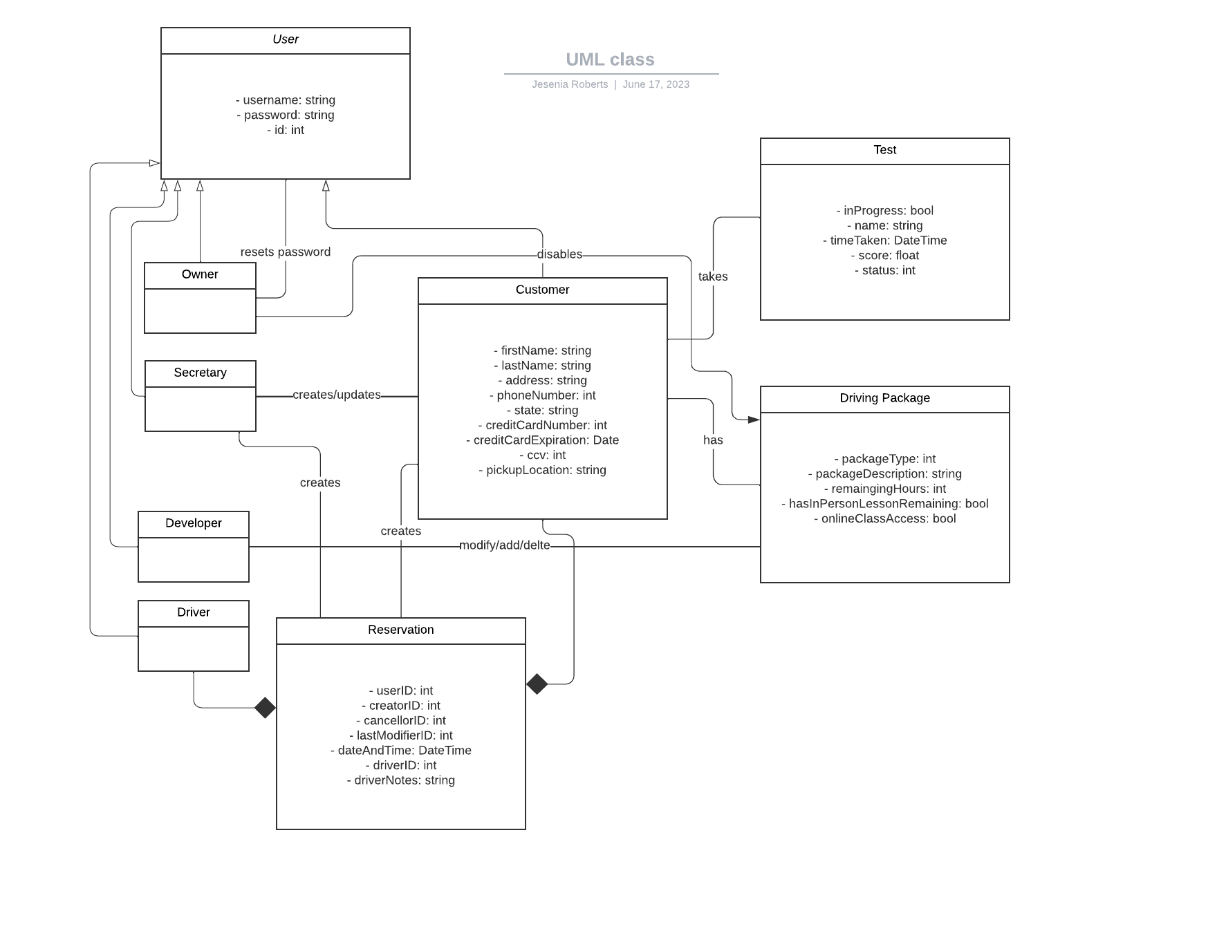

## Technical Requirements

* The system shall validate user credentials when logging in
* The system shall sanitize user input
* The system shall provide practice tests for the user
* The system shall intake user reservations
* The system shall add reservations to the report
* The system shall intake and store pictures and notes that the user uploads
* The system shall store user non-sensitive information via Cloud storage
* The system shall store account information via the database